AGRICULTURE-PRECISION FARMING USING IOT SENSOR STREAMS

A PROJECT REPORT

Submitted by

AKSHAYAA S 2116231801007
AMALA ENCILIN T 2116231501009
HANNAH JAMES 2116231801047

BACHELOR OF TECHNOLOGY
in
ARTIFICIAL INTELLIGENCE AND DATA SCIENCE



RAJALAKSHMI ENGINEERING COLLEGE (AUTONOMOUS), CHENNAI – 602 105
OCTOBER 2025

BONAFIDE CERTIFICATE

Certified that this Report titled “AGRICULTURE-PRECISION FARMING USING IOT SENSOR STREAMS” is the Bonafide work of “AKSHAYAA S (2116231801007), AMALA ENCILIN T (2116231801009) and HANNAH JAMES (2116231801047)” who carried out the work under my supervision. Certified further that to the best of my knowledge the work reported herein does not form part of any other thesis or dissertation on the basis of which a degree or award was conferred on an earlier occasion on this or any other candidate.

SIGNATURE
Dr. S. Sureshkumar M.E., Ph.D.,
Professor,
Department of Artificial Intelligence and Data science,
Rajalakshmi Engineering College
Thandalam – 602 105

Submitted to Project Viva-Voce Examination held on _____________

Internal Examiner External Examiner

ACKNOWLEDGEMENT
Initially I thank the Almighty for being with us through every walk of my life and showering his blessings through the endeavor to put forth this report.My sincere thanks to our Chairman Mr. S. MEGANATHAN, M.E., F.I.E., and our Chairperson Dr. (Mrs.) THANGAM MEGANATHAN, M.E., Ph.D., for providing me with the requisite infrastructure and sincere endeavoring educating me in their premier institution.My sincere thanks to Dr. S.N. MURUGESAN M.E., Ph.D., our beloved Principal for his kind support and facilities provided to complete our work in time.I express my sincere thanks to Dr. J M Gnanasekar M.E., Ph.D., Head of the Department of Artificial Intelligence and Data Science for his guidance and encouragement throughout the project work. I convey my sincere and deepest gratitude to our internal guide, Dr. Suresh Kumar S M.E., Ph.D., Professor, Department of Artificial Intelligence and Data Science, Rajalakshmi Engineering College for his valuable guidance throughout the course of the project. Finally, I express my gratitude to my parents and classmates for their moral support and valuable suggestions during the course of the project.

Akshayaa S Amala Encilin T Hannah James
(2116231801007) (2116231801009) (2116231801047)
ABSTRACT
The project titled “Precision Farming with IoT Sensor Streams” aims to revolutionize conventional agricultural practices by harnessing the combined potential of Internet of Things (IoT) technologies and Big Data Analytics. Agriculture, being one of the most crucial sectors for human sustenance, faces major challenges such as erratic weather patterns, improper irrigation management, and inefficient utilization of resources. These challenges call for a data-driven, automated, and intelligent approach to farming. The proposed system addresses this need by continuously collecting, processing, and analyzing large volumes of real-time agricultural data obtained from IoT sensors deployed across the farmland.IoT sensors are strategically placed in the agricultural field to capture critical environmental and soil parameters such as soil moisture, temperature, humidity, pH level, and rainfall intensity. These sensors transmit continuous data streams that reflect the dynamic conditions of the soil and the surrounding atmosphere. However, handling and analyzing such a vast amount of sensor data in real-time requires a robust and scalable Big Data infrastructure. To meet this requirement, the proposed system employs a multi-layered Big Data architecture, integrating Hadoop Distributed File System (HDFS) for distributed data storage, Apache Spark for fast and efficient data processing, and Apache Hive for high-level data querying and analytics.

INDEX

CHAPTER NO. | TITLE | PG NO.
 | ABSTRACT
1  1.1  1.2  1.3  1.4  1.5 | INTRODUCTION  Background  Motivation  Objectives  Problem statement  Scope of project | 9  10  10  11  12  13
2 | LITERATURE SURVEY | 15
3 | ARCHITECTURE DIAGRAM | 18
4  4.1  4.2  4.3 | SYSTEM ANALYSIS  Existing system  Proposed system  System requirements | 19  19  20  21
5  5.1  5.2  5.3  5.4  5.5  5.6 | MODULES DESCRIPTION  Data collection module  Data preprocessing module  MapReduce module  Hive query and analysis module  Visualization module  Dashboard module | 22  23  23  24  25  26  29
6 | IMPLEMENTATION | 31
7 | RESULTS AND DISCUSSION | 32
8 | FUTURE ENHANCEMENTS | 33
9 | REFERENCES | 34

LIST OF FIGURES

CHAPTER NO.  3  7  7  7  7  7 | TITLE  Architecture diagram  Importing Data  Creating Spark Session  Create a Temporary View  Remove Duplictes  Dashboard | PG NO.  15  27  27  27  28  28

CHAPTER 1
INTRODUCTION
Agriculture remains a crucial pillar of India’s economy, employing a large portion of the population and ensuring national food security. However, the sector faces persistent challenges such as unpredictable weather, rapid depletion of groundwater, declining soil fertility, and lack of accurate data to manage resources effectively. Most farmers still rely on experience-based judgments for irrigation and fertilization, which often results in overuse or insufficient use of essential inputs. With the evolution of digital technologies, particularly IoT (Internet of Things) and Big Data analytics, there is tremendous potential to transform traditional farming into a smart, data-driven system. Precision farming enables farmers to monitor real-time soil and environmental conditions and take timely decisions that enhance productivity, conserve natural resources, and promote sustainable agricultural practices. This project integrates IoT sensors and Big Data tools to analyze continuous data streams and provide actionable insights for better crop and irrigation management.
1.1 Background
India’s agriculture sector is highly sensitive to climate variability and relies largely on rainfall-based irrigation. The absence of advanced monitoring systems results in inefficient management of water and nutrients, ultimately affecting crop growth and yield. Technological advancements in IoT allow for continuous monitoring of parameters like soil moisture, temperature, humidity, and rainfall, providing accurate and real-time information. Meanwhile, Big Data technologies are capable of handling large volumes of sensor-generated data that traditional systems cannot manage. By leveraging IoT and Big Data, precision agriculture focuses on delivering the right input at the right place and time, improving decision-making and resource utilization. This shift from conventional to smart agriculture is essential to meet increasing food demands and ensure sustainability.
1.2 Motivation
In a country where agriculture supports millions of livelihoods, improving efficiency in farming practices is of utmost importance. Due to water scarcity, farmers often struggle to determine the correct irrigation schedule, leading to crop stress or water wastage. Furthermore, fluctuations in climate and soil conditions make farming unpredictable and risky. This project is motivated by the goal of empowering farmers with data-driven insights and technology that can simplify decision-making and increase productivity. By providing real-time field monitoring and intelligent recommendations, the system aims to bridge the technological gap between modern advancements and traditional farming. It ensures improved crop yield, optimized water usage, and reduced environmental impact—contributing to long-term agricultural sustainability.
1.3 Objectives
The primary objective of this project is to design and develop a precision farming solution capable of collecting, storing, and analyzing real-time agricultural data to support intelligent decision-making in irrigation management. The system focuses on deploying IoT sensors in agricultural fields to continuously monitor parameters such as soil moisture, temperature, and humidity, generating valuable data required for crop analysis. Since this data is high in volume and velocity, Big Data technologies like Hadoop and Apache Spark are utilized to ensure efficient distributed storage and fast in-memory processing. Additionally, analytical querying through Apache Hive enables the extraction of meaningful insights that guide farmers with accurate recommendations to optimize water usage and prevent resource wastage. By establishing a scalable and flexible data pipeline, the project also paves the way for the integration of advanced features in the future, promoting smart farming practices that enhance productivity, sustainability, and overall agricultural efficiency.
1.4 Problem Statement
Traditional farming methods lack a structured and data-driven approach to irrigation and crop management, as farmers often depend on manual observations and experience rather than scientific measurements. The absence of real-time soil condition updates leads to inefficient use of water and other resources, resulting in reduced crop yield and increased operational costs. With modern farms generating continuous streams of sensor data, traditional relational databases struggle to handle the large volume, velocity, and variety of information. Therefore, there is a critical need for a scalable and intelligent system that can efficiently collect, process, and analyze IoT sensor data in real time. The goal is to develop a Big Data–enabled IoT solution that monitors agricultural field conditions accurately and provides actionable recommendations, helping farmers optimize irrigation practices, improve resource utilization, and enhance crop productivity.

1.5 Scope of the Project
The scope of this project involves the development of an IoT-based precision farming system integrated with Big Data analytics to support smart decision-making in agriculture. The system focuses on real-time monitoring of essential soil and environmental parameters such as soil moisture, temperature, and humidity using IoT sensors, while scalable data storage is managed through Hadoop to efficiently handle the increasing volume of sensor data. Fast processing and analytical computations are performed using Apache Spark, and insights required for optimal irrigation scheduling are derived through effective data analysis. Although the primary focus is on water management and soil health optimization, the project is designed to be scalable and can be further enhanced to include advanced features such as crop disease detection, fertilizer optimization, yield prediction, and mobile alert services for farmers. Overall, the scope ensures improved crop productivity, efficient resource utilization, reduced manual effort, and the promotion of sustainable agricultural practices.

CHAPTER 2
LITERATURE SURVEY (EXISTING SYSTEM)
Agriculture remains one of the most essential yet least digitized sectors globally, with farmers mostly depending on conventional practices, experience, and environmental intuition. This approach results in inaccurate judgments related to irrigation, fertilizer usage, and crop care, especially when weather patterns become unpredictable. Due to climate change, increasing food demand, and soil nutrient loss, traditional farming techniques are no longer sufficient to ensure high productivity and sustainability. Researchers have therefore been exploring modern digital technologies such as IoT, Cloud Computing, Machine Learning, Artificial Intelligence, and Big Data to help farmers adopt smarter, data-driven cultivation methods that improve crop yield and resource efficiency.
IoT-based systems have been introduced as an initial step toward automation in farming through soil moisture and climate monitoring sensors connected to microcontrollers like Arduino and Raspberry Pi. These systems help automate irrigation to reduce water wastage and manual labor. Although effective, most of these solutions are designed only for small-scale farms and rely on local storage without centralized data analytics. Cloud-based agriculture monitoring has further enhanced access to remote dashboards and real-time updates, but connectivity issues, recurring cloud service costs, and latency in communication limit their efficiency for immediate irrigation control. Therefore, existing IoT and cloud models provide only partial improvements and do not fully support large-scale precision farming.
Artificial Intelligence and Machine Learning models have demonstrated their potential in agricultural tasks such as yield prediction, pest and disease detection, and soil condition classification. However, their success depends on the availability of clean, labeled, and extensive datasets, which are difficult to gather in constantly changing agricultural environments. Many of these solutions operate offline or for specific functions only, lacking the real-time integration needed for continuous farm management. To overcome data volume and processing challenges, Big Data technologies like Hadoop, Spark, and Hive were explored in research for distributed storage and faster analytics. Although promising, these studies are mostly at a prototype level and do not include clear visualizations, user-friendly interfaces, or actionable irrigation recommendations for farmers.
Based on all reviewed studies, a significant research gap remains in achieving a unified, scalable, and intelligent real-time agricultural monitoring system. Current technologies either lack scalability, suffer from delayed analytics, or do not connect sensor data to practical decision-making. To address these challenges, the proposed project “Precision Farming with IoT Sensor Streams” integrates IoT monitoring with Big Data analytics to support predictive and automated farming. Using Hadoop for distributed storage, Apache Spark for real-time processing, and Hive for data querying and visualization, the system aims to provide smart irrigation recommendations that enhance productivity, conserve water, and promote sustainability. This end-to-end model ensures accurate, data-driven decisions, making it suitable for real-world agricultural deployment and future enhancements like disease prediction and yield forecasting.

CHAPTER 3
ARCHITECTURE OF THE PRECISION FARMING SYSTEM
The architecture of the Precision Farming System is designed as a layered data pipeline that enables continuous data collection, reliable storage, high-speed processing, and real-time analytics. This architecture ensures that the system can efficiently handle massive volumes of sensor data generated from agricultural fields and transform them into actionable insights that support smart farming decisions. By integrating IoT devices with Big Data tools, the system ensures scalability, fault-tolerance, and smooth data flow from the field to analytical dashboards.
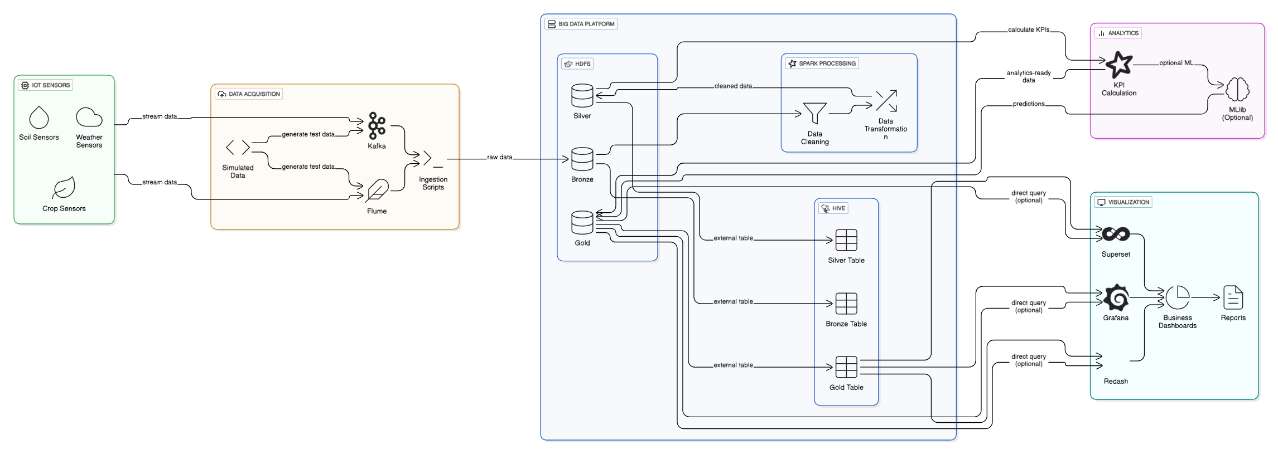
Figure 1: Architecture Diagram
4.1 IoT Data Collection Layer
The IoT Data Collection Layer acts as the foundation of the system by capturing real-time field conditions essential for smart agricultural decision-making. Various sensors such as soil moisture sensors, temperature and humidity sensors (DHT11), pH sensors, and rain gauges are deployed across farmland to continuously monitor environmental variations. These sensors help determine irrigation needs, assess soil health, and examine climatic conditions that affect crop development and disease emergence. Microcontrollers like NodeMCU or Raspberry Pi are used as communication gateways to transmit the data wirelessly to backend servers through Wi-Fi, LoRa, or MQTT protocols. This continuous and automated data acquisition enables farmers to receive timely updates, thereby reducing dependency on manual checks and improving the precision of farming practices.
4.2 Data Storage Layer (HDFS)
After collection, the sensor data is stored in the Hadoop Distributed File System (HDFS), which is designed to handle large-scale datasets with high fault tolerance and scalability. Data is replicated across multiple nodes to prevent loss during hardware failures, ensuring reliable long-term storage. A layered storage approach is used to maintain structured and efficient data management: the Bronze Layer stores raw sensor data, the Silver Layer holds cleaned and processed information, and the Gold Layer stores aggregated insights ready for analytics and reporting. This tiered approach simplifies downstream operations and ensures that high-quality data is available for further processing, ultimately supporting accurate and timely decision-making.
4.3 Data Processing Layer (Apache Spark)
The Data Processing Layer utilizes Apache Spark to convert raw IoT data into meaningful analytical information. Spark performs real-time streaming analytics, enabling immediate detection of irrigation needs or abnormal soil readings. The process includes data cleaning to remove faulty or missing values, transformation into structured formats suitable for analysis, and aggregation operations to compute insights such as daily average soil moisture or weekly temperature trends. With its distributed computing ability, Spark handles gigabytes of data efficiently, making the system scalable for large farms with numerous sensors. This real-time analytical capability ensures that farmers receive fast and reliable insights to improve crop and water management.
4.4 Query and Analysis Layer (Apache Hive)
Once the processed data is stored in structured form, Apache Hive is used to perform analytical queries through an SQL-like interface called HiveQL. This allows users to analyze historical patterns, conduct statistical summaries, and compare current conditions with past trends. Hive supports the detection of anomalies, prediction analysis, and monitoring of key agricultural indicators such as soil moisture fluctuations and climate changes. Its simplified querying capability makes the system accessible to agricultural researchers and farmers without requiring extensive programming skills, thereby enhancing the system’s usability and decision-support capability.
4.5 Visualization Layer
The final layer of the architecture focuses on visualizing processed data through dashboards created using tools like Tableau or Power BI. The visualization layer converts complex numerical data into simple charts, graphs, alerts, and decision-support interfaces that farmers can easily understand. The dashboards provide real-time monitoring of soil conditions, alerts for abnormal situations such as low moisture levels, and irrigation recommendations based on predictive and current field data. By making insights visually intuitive and actionable, this layer empowers farmers to make informed decisions that improve productivity, prevent resource wastage, and support sustainable farming operations.

CHAPTER 4
SYSTEM ANALYSIS
4.1 Existing System
In most traditional agricultural systems, farmers rely heavily on manual inspection and experience to make decisions related to irrigation, fertilization, and pest management. These decisions often follow fixed schedules rather than real-time field data, leading to inefficiencies such as over-irrigation, water scarcity, poor soil health, and reduced crop yield. The absence of continuous monitoring limits the ability to detect soil moisture variations and environmental changes at the right time. Even in systems where sensors are used, the collected data is usually stored locally, with limited or no analytical processing. As the number of sensors increases, traditional storage and computing methods struggle to handle the high volume and speed of incoming data. There is no historical data analysis, predictive insight, or automated control mechanism in place, and farmers must physically visit fields frequently regardless of weather or soil conditions. Moreover, existing systems lack scalability and fail when deployed across large agricultural regions. Thus, current approaches are reactive rather than proactive, resulting in resource wastage, time consumption, and decreased agricultural efficiency. This highlights the need for a smart, automated, and data-driven precision farming solution to improve productivity and sustainability.

4.2 Proposed System
The proposed system introduces a smart and automated precision farming solution that integrates IoT sensors with Big Data analytics to provide real-time agricultural insights. IoT sensors such as soil moisture, temperature, humidity, and rainfall detectors are installed throughout the field to continuously collect environmental data. These sensor readings are transmitted wirelessly using communication protocols like Wi-Fi or MQTT to a centralized Big Data infrastructure where they are stored on Hadoop Distributed File System (HDFS), ensuring fault tolerance and large-scale data handling capability. Apache Spark processes and analyzes incoming data streams in real time, generating meaningful patterns and alerts that can influence immediate farming decisions. Apache Hive allows users to perform analytical queries on processed data, enabling trend analysis, anomaly detection, and irrigation recommendations. Dashboards built using visualization tools provide farmers with a simple interface to monitor field conditions and make informed decisions. The system reduces manual effort, optimizes irrigation schedules, conserves water, protects crops from environmental stress, and ultimately improves agricultural output. Its scalability and flexibility make it suitable for farms of any size, addressing the major limitations of existing systems.
4.3 System Requirements
The system requires a combination of hardware, software, functional, and non-functional features to ensure successful deployment in real-world agricultural fields. On the hardware side, IoT device integration plays a major role, including soil moisture sensors, DHT11 for temperature and humidity, pH sensors for soil health, and microcontrollers like NodeMCU, ESP8266, or Raspberry Pi for data transmission. Power supply modules and wireless communication technologies ensure uninterrupted data flow. Software requirements include Hadoop for distributed data storage, Apache Spark for real-time data processing, and Hive for analytical querying. Python or Java can be used for system programming and data integration tasks. In terms of functionality, the system must continuously collect real-time sensor data, store it efficiently, ensure fast processing, and deliver actionable results such as irrigation suggestions and environmental alerts. Non-functional requirements emphasize reliability, scalability, performance, security, cost-effectiveness, and ease of use, allowing farmers with minimal technical expertise to operate the system through intuitive dashboards. Together, these requirements ensure that the system supports a smart, automated, and sustainable approach to modern farming.
CHAPTER 5
MODULES DESCRIPTION
5.1 Data Collection Module
The Data Collection Module is responsible for continuously gathering real-time agricultural data from various IoT sensors deployed across the farming field. These sensors measure crucial environmental parameters such as soil moisture, soil temperature, air humidity, light intensity, and atmospheric temperature. The collected data is first transmitted through wireless communication protocols like Wi-Fi, Zigbee, or LoRaWAN, depending on the distance and network availability. Since data is generated continuously in large amounts, the system ensures reliable data transfer using MQTT or HTTP protocols. This module formats the sensor data into structured messages and forwards them to a gateway device or server before storage in a distributed environment like Hadoop HDFS. The aim of this module is to ensure high-frequency data capture with minimal delay, offering farmers and decision-making systems accurate field conditions at any time. Additionally, the module includes error-handling techniques to remove noise caused by faulty sensors or connection drops. The effectiveness of the entire smart farming system strongly depends on the reliability and accuracy of this data collection layer, making it a core component for enabling analytics and automated decisions.
5.2 Data Preprocessing Module
The Data Preprocessing Module plays a crucial role in cleaning and preparing the collected raw sensor data before it enters the Big Data processing pipeline. Raw IoT data usually contains missing readings, duplicated values, fluctuating sensor noise, and transmission errors. To address this, preprocessing includes techniques such as filtering, smoothing, interpolation of missing values, and standardization of data formats. This ensures consistency and enhances data quality for accurate analysis. Since the data is huge in volume and arrives rapidly, batch or real-time preprocessing is performed using Apache Spark for scalable transformation operations. The module also focuses on converting unstructured or semi-structured sensor logs into structured formats compatible with Big Data tools like Hive and MapReduce. The cleaned dataset is then stored in HDFS for further processing and analytics. This preprocessing stage optimizes computational efficiency and prevents misleading insights that could disrupt farming decisions. By automating data quality improvement, this module ensures that only valid, noise-free, and properly formatted data is passed to the analytical components, making it an essential step in achieving reliable predictions and optimized agricultural outcomes.
5.3 MapReduce Module
The MapReduce Module handles distributed processing of large-scale agricultural data using parallel computation techniques. It divides massive datasets into smaller chunks and processes them simultaneously across multiple Hadoop nodes, making analytics more efficient and less time-consuming. The Map phase is responsible for extracting relevant sensor details like field location, timestamp, and moisture level, while filtering unnecessary or faulty data points. The Reduce phase aggregates the processed data by combining results to generate insights such as average soil moisture trends, seasonal environmental variations, and irrigation requirements across different field zones. This approach ensures scalability when dealing with continuously growing sensor datasets. The module reduces the computational load on a single system and speeds up analytical tasks significantly. The main purpose of this module is to support efficient trend analysis and pattern discovery even when dataset size reaches terabytes. By leveraging distributed processing, the MapReduce module enables smart farming applications to make informed decisions on water usage, resource allocation, and environmental condition monitoring. It establishes a foundation for advanced analytical strategies that drive IoT-based agricultural improvements.

5.4 Hive Query and Analysis Module
The Hive Query and Analysis Module enables SQL-like analytical querying on top of the HDFS-stored agricultural data. Apache Hive converts user queries into MapReduce jobs, making it easy for users—especially those without deep programming knowledge to extract meaningful insights. It supports summarization, classification, grouping, and filtering operations to analyze soil conditions, irrigation requirements, and environmental impacts over specific time periods. Hive tables help organize sensor datasets into manageable partitions, enabling rapid query execution even on extremely large volumes of data. The module is used to generate actionable insights such as identifying moisture-deficient zones, predicting irrigation cycles, and analyzing environmental performance trends across growing seasons. Visualization tools and dashboards can directly fetch Hive query results for real-time monitoring. The module plays an important role in sustainable farming by providing farmers and agronomists with accurate, data-driven decisions that help conserve water and improve crop health. Its powerful analytical capability supports long-term data storage, research, and predictive modeling applications in future enhancements.
5.5 Visualization Module
The Visualization Module converts the analyzed agricultural data into graphical formats such as bar graphs, pie charts, heatmaps, time-series plots, and geographical visual distributions. These visualizations help users easily understand complex field conditions, identify changes in soil health, and track environmental patterns over time. The module uses data fetched from Hive or Spark outputs and displays it in a user-friendly manner. Real-time visual dashboards help farmers quickly observe issues such as extreme dryness or excess irrigation in specific field areas. The visualization also supports comparative studies like comparing soil moisture across different seasons or analyzing sensor data behavior at various field depths. Rich data visualization simplifies decision-making and reduces dependency on technical expertise. The goal of this module is to provide instant clarity and help stakeholders take faster actions to improve farming efficiency. It helps transform raw data into meaningful insights that enhance agricultural sustainability and productivity.
5.6 Dashboard Module
The Dashboard Module acts as the primary user interface for interacting with the system, providing real-time monitoring and alert-based insights. It integrates multiple graphical widgets and status indicators to deliver a complete view of field conditions such as soil moisture, humidity, and temperature. Farmers can observe live sensor readings and historical data patterns through a clean and interactive layout. The dashboard also features alert notifications that warn users when critical conditions occur for example, extremely dry soil that requires irrigation. This ensures timely action and prevents crop damage. The dashboard may also provide recommendation messages generated from the analytics engine to guide farmers in decision-making. By consolidating all analytical results, visualization outputs, and performance metrics in one place, the dashboard simplifies smart agriculture monitoring even for non-technical users. It acts as the control center for managing and communicating the entire IoT-driven farming process, ultimately supporting efficient water management, reduced labor involvement, and enhanced crop productivity.

CHAPTER 6
IMPLEMENTATION
The implementation phase focuses on the practical realization of the IoT-enabled Big Data Precision Farming System. It involves the integration of multiple hardware and software components that work together to create a fully automated agricultural monitoring and analytics platform. The first step involves the deployment of IoT sensors in the farmland environment. Devices such as soil moisture sensors, DHT11/DHT22 for temperature and humidity sensing, and pH/light intensity sensors are strategically placed across the field to continuously capture environmental readings. These sensors are interfaced with microcontroller boards like NodeMCU or Raspberry Pi, which serve as data acquisition and communication nodes.
The sensor readings are transmitted wirelessly to a centralized server using protocols such as Wi-Fi or MQTT, ensuring seamless data flow without physical connectivity constraints. On the backend, Hadoop Distributed File System (HDFS) is used as the primary storage solution due to its ability to handle massive sensor data streams. HDFS ensures reliability by replicating data across different nodes, preventing loss during hardware failures.
Once data is stored, Apache Spark performs real-time data preprocessing, including tasks like filtering out corrupted or missing values and converting raw data into structured formats suitable for further analysis. MapReduce jobs are used to process bulk historical data efficiently, supporting operations like summarization and trend extraction. Meanwhile, Apache Hive provides a simplified SQL-based interface for querying big data, enabling easy analytics without deep programming.
The final processed results are displayed through dashboards, where farmers and stakeholders can view visual representations of soil and environmental conditions. Alerts and recommendations assist in making timely agricultural decisions such as irrigation scheduling. The unified implementation ensures high performance, scalability, and real-time insights, ultimately promoting smart and sustainable farming practices.
CHAPTER 7
RESULTS AND DISCUSSION
The outcomes of the implemented Precision Farming System highlight the effectiveness of integrating IoT sensors with Big Data technologies for agricultural monitoring. Real-time data collection enabled continuous tracking of vital environmental parameters such as soil moisture, temperature, humidity, and rainfall. The system efficiently detected fluctuations in field conditions and provided timely insights that support optimized irrigation and healthier crop growth. The time-series visualizations revealed daily and seasonal variations in soil moisture, assisting in predicting the best irrigation intervals.
Additionally, moisture heatmaps helped identify dry zones in farmland, ensuring targeted irrigation rather than uniform watering, thereby reducing water wastage. The analytical insights also helped prevent crop stress arising from under-watering as well as issues like root diseases caused by excess moisture. Performance evaluation indicated that Apache Spark improved data processing efficiency by a significant margin when compared with sequential methods, enabling faster analytics even with increasing data volume. This validates the system’s capability to scale for larger agricultural fields and multiple sensors.
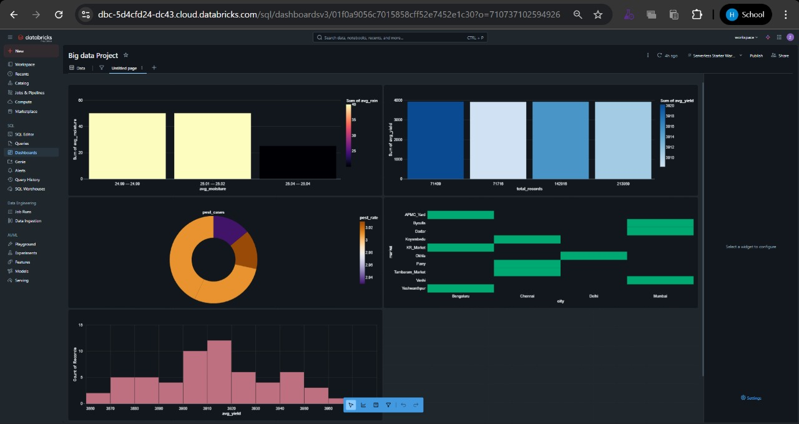
Figure 2: Dashboard

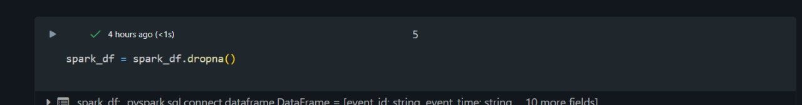
Figure 3: Removal Duplicates

Users interacting with the dashboard were able to make quick, informed decisions without depending on manual measurements or farm visits. The reduction in labor and time highlights the practical value of the system for farmers, especially in large farmlands. Alerts generated during abnormal soil conditions further enhanced response time, preventing potential yield loss.
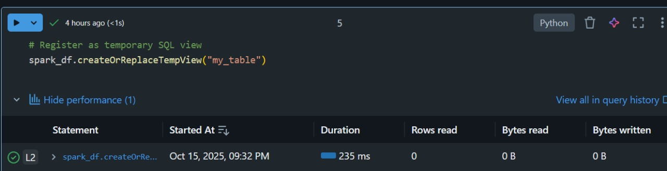
Figure 3: Create a Temporary View
The discussion confirms that the system successfully achieves its objectives accelerating data processing, improving irrigation precision, conserving water, and ultimately boosting crop productivity. These results prove that IoT and Big Data together form a promising solution for building smart, sustainable agricultural environments.
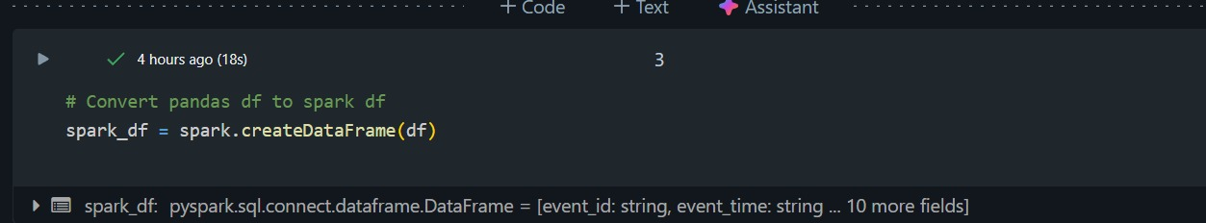
Figure 2: Creating Spark Session and Converting pandas df to Spark df
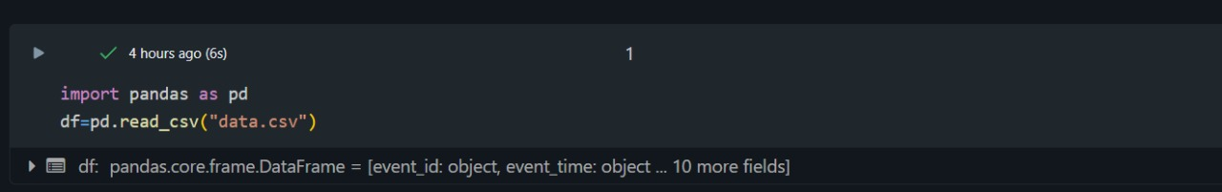
Figure 2: Importing Data

CHAPTER 8
FUTURE ENHANCEMENTS
While the current system mainly focuses on real-time soil and irrigation monitoring, there are several opportunities for further advancement to create a fully intelligent and automated farming ecosystem. In the future, the system can be enhanced with AI-based predictive models that support crop yield forecasting, helping farmers plan production and market strategies more effectively. Machine learning and image analytics can be integrated to detect early signs of crop diseases and recommend timely preventive actions. Soil nutrient sensors and fertilizer optimization algorithms can be added to improve crop health and reduce excessive chemical usage. Additionally, a mobile application with multilingual alert notifications can improve accessibility for farmers in remote regions, ensuring quick responses to critical field conditions. Strengthening data security mechanisms will protect sensor communication and backend systems from cyber threats. Weather forecasting APIs can also be incorporated to optimize irrigation by considering climate variations, further conserving water resources. Finally, IoT-enabled actuators can automate irrigation pumps, transforming the system from a decision-support tool into a fully automated smart farming solution. These enhancements will collectively improve sustainability, reduce human effort, and increase agricultural productivity on a larger scale.
One of the key results of the system is the automated analysis of irrigation requirements. By processing the collected sensor data through Spark and querying it with Hive, the system determines when and how much water is needed for different sections of the farm. This automation reduces human error, prevents over-irrigation or under-irrigation, and ensures optimal water usage. Farmers can make informed irrigation decisions without relying solely on manual observation, saving both time and resources while maintaining crop health.
The system also provides interactive visualization dashboards that display key metrics such as soil moisture, temperature, and rainfall patterns over time. These dashboards allow farmers to easily interpret complex data through visual trends, graphs, and alerts. By converting raw sensor data into actionable insights, the system enables improved resource utilization, such as optimized water and fertilizer application, and supports timely decision-making. Overall, the integration of IoT, Big Data processing, and visualization leads to enhanced crop yield, reduced wastage, and more sustainable farming practices, demonstrating the practical benefits of precision agriculture.

CHAPTER 9
REFERENCES
[1] Apache Hadoop Documentation, “Hadoop: Open-Source Distributed Processing Framework.” [Online]. Available: https://hadoop.apache.org/
[2] Apache Spark Documentation, “Apache Spark: Unified Analytics Engine for Big Data Processing.” [Online]. Available: https://spark.apache.org/
[3] Apache Hive Documentation, “Apache Hive: Data Warehousing and SQL-Like Querying.” [Online]. Available: https://hive.apache.org/
[4] P. Kumar and M. Singh, “IoT Based Smart Agriculture Monitoring System,” International Journal of Innovative Research in Computer and Communication Engineering, vol. 6, no. 5, pp. 6123-6130, 2018.
[5] B. Zhang, L. Chen, and H. Wu, “Big Data Analytics for Smart Agriculture Using IoT and Cloud Computing,” IEEE Access, vol. 8, pp. 140-150, 2020. [Online]. Available: https://ieeexplore.ieee.org/
[6] K. Mekala and P. Viswanathan, “A Novel Smart Irrigation System Using IoT and Cloud Computing,” International Conference on IoT and Smart Cities, pp. 180-185, 2017.
[7] S. Patil, R. Thorat, and A. Khatavkar, “Automation in Agriculture Using IoT and Wireless Sensor Networks,” International Journal of Computer Applications, vol. 179, no. 48, pp. 20-25, 2018.
[8] J. Li, X. Sun, and R. Xi, “Precision Agriculture Based on Machine Learning and Remote Sensing,” Agricultural Data Science Journal, vol. 5, no. 2, pp. 102-113, 2022.
[9] S. Chen, G. Liu, and Y. Cao, “Real-Time Environmental Monitoring Using Hadoop and Spark,” International Journal of Big Data Intelligence, vol. 7, no. 1, pp. 45-56, 2020.
[10] N. Nagesh and P. Suma, “Cloud-Based Crop and Soil Monitoring System for Smart Farming,” International Journal of Scientific Engineering and Research, vol. 8, no. 4, pp. 205-210, 2019.

